UNITED STATES
SECURITIES AND EXCHANGE COMMISSION
WASHINGTON, D.C. 20549

FORM 8-K

CURRENT REPORT

Pursuant to Section 13 or 15(d) of the
Securities Exchange Act of 1934

Date of Report (date of earliest event reported): July 9, 2026

ZAPATA QUANTUM, INC.
(Exact name of registrant as specified in charter)

Delaware |  | 001-41218 |  | 98-1578373
(State or other jurisdiction  of incorporation) |  | (Commission File Number) |  | (I.R.S. Employer  Identification No.)

6 Liberty Square, #2488
Boston, MA 02109
(Address of principal executive offices and zip code)

Registrant’s telephone number, including area code: (857) 367-9002

(Former Name and Former Address)

Check the appropriate box below if the Form 8-K filing is intended to simultaneously satisfy the filing obligation of registrant under any of the following provisions:

 | ☐ | Written communications pursuant to Rule 425 under the Securities Act (17 CFR 230.425)

 | ☐ | Soliciting material pursuant to Rule 14a-12(b) under the Exchange Act (17 CFR 240.14a-12)

 | ☐ | Pre-commencement communications pursuant to Rule 14d-2(b) under the Exchange Act (17 CFR 240.14d-2(b))

 | ☐ | Pre-commencement communications pursuant to Rule 13e-4(c) under the Exchange Act (17 CFR 240.13e-4(c))

Indicate by check mark whether the registrant is an emerging growth company as defined in Rule 405 of the Securities Act of 1933 (§230.405 of this chapter) or Rule 12b-2 of the Securities Exchange Act of 1934 (§240.12b-2 of this chapter).

Emerging growth company ☒

If an emerging growth company, indicate by checkmark if the registrant has elected not to use the extended transition period for complying with any new or revised financial accounting standards provided pursuant to Section 13(a) of the Exchange Act. ☐

Item 7.01 Regulation FD Disclosure.

As previously disclosed, on July 9, 2026, Sumit Kapur, the Chief Executive Officer of Zapata Quantum, Inc. (the “Company”) presented at the Global Technology Virtual Investor Conference. A copy of the slide presentation used for the presentation is furnished herewith as Exhibit 99.1 of this Current Report on Form 8-K.

The information in this Item 7.01 (including Exhibit 99.1) shall not be deemed “filed” for purposes of Section 18 of the Securities Exchange Act of 1934 (the “Exchange Act”) or otherwise subject to the liabilities under such section, and shall not be deemed to be incorporated by reference into any filing of the Company under the Securities Act of 1933 or the Exchange Act.

Item 9.01 Financial Statements and Exhibits.

(d) Exhibits

 |  |  |  | Incorporated by Reference |  |  |  |  |  | Filed or  Furnished
Exhibit # |  | Exhibit Description |  | Form |  | Date |  | Number |  | Herewith
99.1 |  | Investor Presentation dated July 9, 2026 |  |  |  |  |  |  |  | Furnished
104 |  | Cover Page Interactive Data File (formatted in iXBRL, and included in exhibit 101)

2

SIGNATURE

Pursuant to the requirements of the Securities Exchange Act of 1934, the registrant has duly caused this report to be signed on its behalf by the undersigned hereunto duly authorized.

Date: July 9, 2026

 | ZAPATA QUANTUM, INC.
 | By: | /s/ Sumit Kapur
 |  | Sumit Kapur, Chief Executive Officer

3

Exhibit 99.1

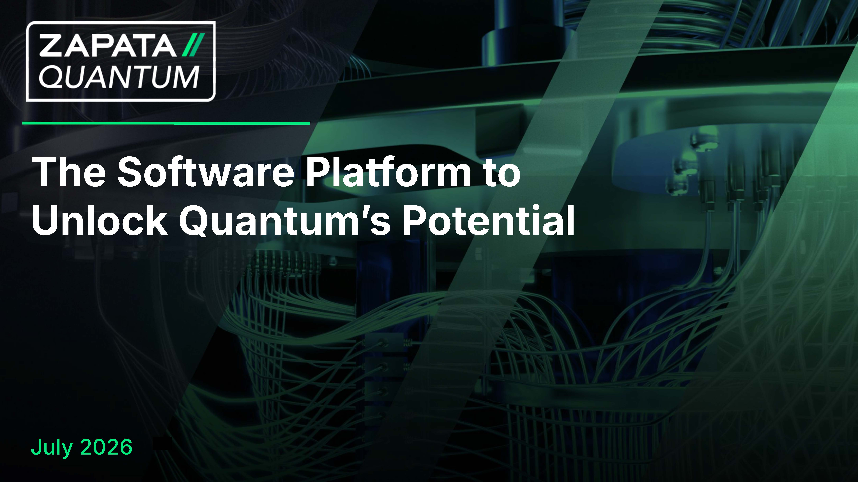
The Software Platform to Unlock Quantumʼs Potential July 2026
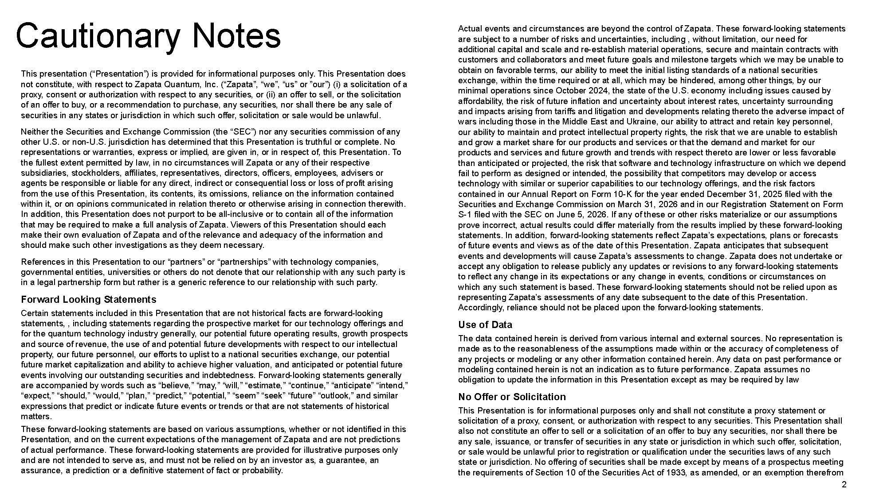
Actual events and circumstances are beyond the control of Zapata. These forward - looking statements are subject to a number of risks and uncertainties, including , without limitation, our need for additional capital and scale and re - establish material operations, secure and maintain contracts with customers and collaborators and meet future goals and milestone targets which we may be unable to obtain on favorable terms, our ability to meet the initial listing standards of a national securities exchange, within the time required or at all, which may be hindered, among other things, by our minimal operations since October 2024, the state of the U.S. economy including issues caused by affordability, the risk of future inflation and uncertainty about interest rates, uncertainty surrounding and impacts arising from tariffs and litigation and developments relating thereto the adverse impact of wars including those in the Middle East and Ukraine, our ability to attract and retain key personnel, our ability to maintain and protect intellectual property rights, the risk that we are unable to establish and grow a market share for our products and services or that the demand and market for our products and services and future growth and trends with respect thereto are lower or less favorable than anticipated or projected, the risk that software and technology infrastructure on which we depend fail to perform as designed or intended, the possibility that competitors may develop or access technology with similar or superior capabilities to our technology offerings, and the risk factors contained in our Annual Report on Form 10 - K for the year ended December 31, 2025 filed with the Securities and Exchange Commission on March 31, 2026 and in our Registration Statement on Form S - 1 filed with the SEC on June 5, 2026. If any of these or other risks materialize or our assumptions prove incorrect, actual results could differ materially from the results implied by these forward - looking statements. In addition, forward - looking statements reflect Zapata’s expectations, plans or forecasts of future events and views as of the date of this Presentation. Zapata anticipates that subsequent events and developments will cause Zapata’s assessments to change. Zapata does not undertake or accept any obligation to release publicly any updates or revisions to any forward - looking statements to reflect any change in its expectations or any change in events, conditions or circumstances on which any such statement is based. These forward - looking statements should not be relied upon as representing Zapata’s assessments of any date subsequent to the date of this Presentation. Accordingly, reliance should not be placed upon the forward - looking statements. Use of Data The data contained herein is derived from various internal and external sources. No representation is made as to the reasonableness of the assumptions made within or the accuracy of completeness of any projects or modeling or any other information contained herein. Any data on past performance or modeling contained herein is not an indication as to future performance. Zapata assumes no obligation to update the information in this Presentation except as may be required by law No Offer or Solicitation This Presentation is for informational purposes only and shall not constitute a proxy statement or solicitation of a proxy, consent, or authorization with respect to any securities. This Presentation shall also not constitute an offer to sell or a solicitation of an offer to buy any securities, nor shall there be any sale, issuance, or transfer of securities in any state or jurisdiction in which such offer, solicitation, or sale would be unlawful prior to registration or qualification under the securities laws of any such state or jurisdiction. No offering of securities shall be made except by means of a prospectus meeting the requirements of Section 10 of the Securities Act of 1933, as amended, or an exemption therefrom 2 Cautionary Notes This presentation (“Presentation”) is provided for informational purposes only. This Presentation does not constitute, with respect to Zapata Quantum, Inc. (“Zapata”, “we”, “us” or ”our”) (i) a solicitation of a proxy, consent or authorization with respect to any securities, or (ii) an offer to sell, or the solicitation of an offer to buy, or a recommendation to purchase, any securities, nor shall there be any sale of securities in any states or jurisdiction in which such offer, solicitation or sale would be unlawful. Neither the Securities and Exchange Commission (the “SEC”) nor any securities commission of any other U.S. or non - U.S. jurisdiction has determined that this Presentation is truthful or complete. No representations or warranties, express or implied, are given in, or in respect of, this Presentation. To the fullest extent permitted by law, in no circumstances will Zapata or any of their respective subsidiaries, stockholders, affiliates, representatives, directors, officers, employees, advisers or agents be responsible or liable for any direct, indirect or consequential loss or loss of profit arising from the use of this Presentation, its contents, its omissions, reliance on the information contained within it, or on opinions communicated in relation thereto or otherwise arising in connection therewith. In addition, this Presentation does not purport to be all - inclusive or to contain all of the information that may be required to make a full analysis of Zapata. Viewers of this Presentation should each make their own evaluation of Zapata and of the relevance and adequacy of the information and should make such other investigations as they deem necessary. References in this Presentation to our “partners” or “partnerships” with technology companies, governmental entities, universities or others do not denote that our relationship with any such party is in a legal partnership form but rather is a generic reference to our relationship with such party. Forward Looking Statements Certain statements included in this Presentation that are not historical facts are forward - looking statements, , including statements regarding the prospective market for our technology offerings and for the quantum technology industry generally, our potential future operating results, growth prospects and source of revenue, the use of and potential future developments with respect to our intellectual property, our future personnel, our efforts to uplist to a national securities exchange, our potential future market capitalization and ability to achieve higher valuation, and anticipated or potential future events involving our outstanding securities and indebtedness. Forward - looking statements generally are accompanied by words such as “believe,” “may,” “will,” “estimate,” “continue,” “anticipate” “intend,” “expect,” “should,” “would,” “plan,” “predict,” “potential,” “seem” “seek” “future” “outlook,” and similar expressions that predict or indicate future events or trends or that are not statements of historical matters. These forward - looking statements are based on various assumptions, whether or not identified in this Presentation, and on the current expectations of the management of Zapata and are not predictions of actual performance. These forward - looking statements are provided for illustrative purposes only and are not intended to serve as, and must not be relied on by an investor as, a guarantee, an assurance, a prediction or a definitive statement of fact or probability.
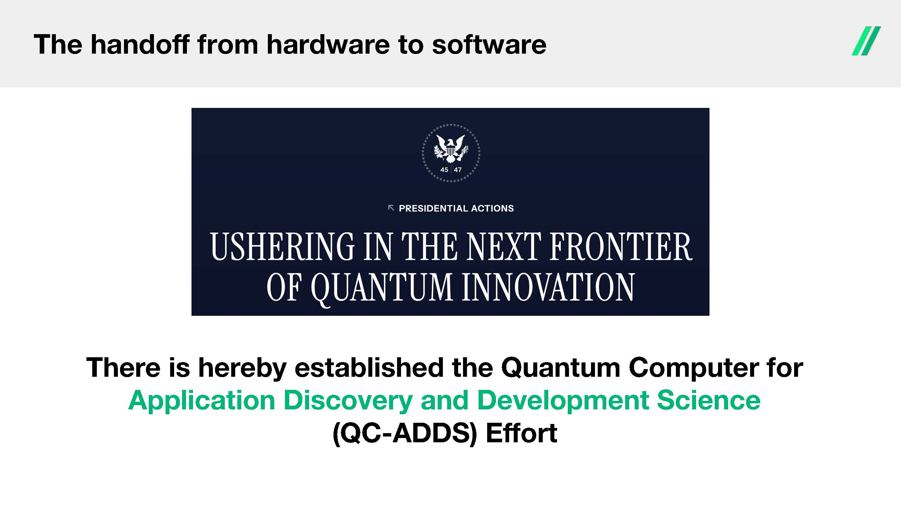
The handoﬀ from hardware to software There is hereby established the Quantum Computer for Application Discovery and Development Science (QC - ADDS) Eﬀort
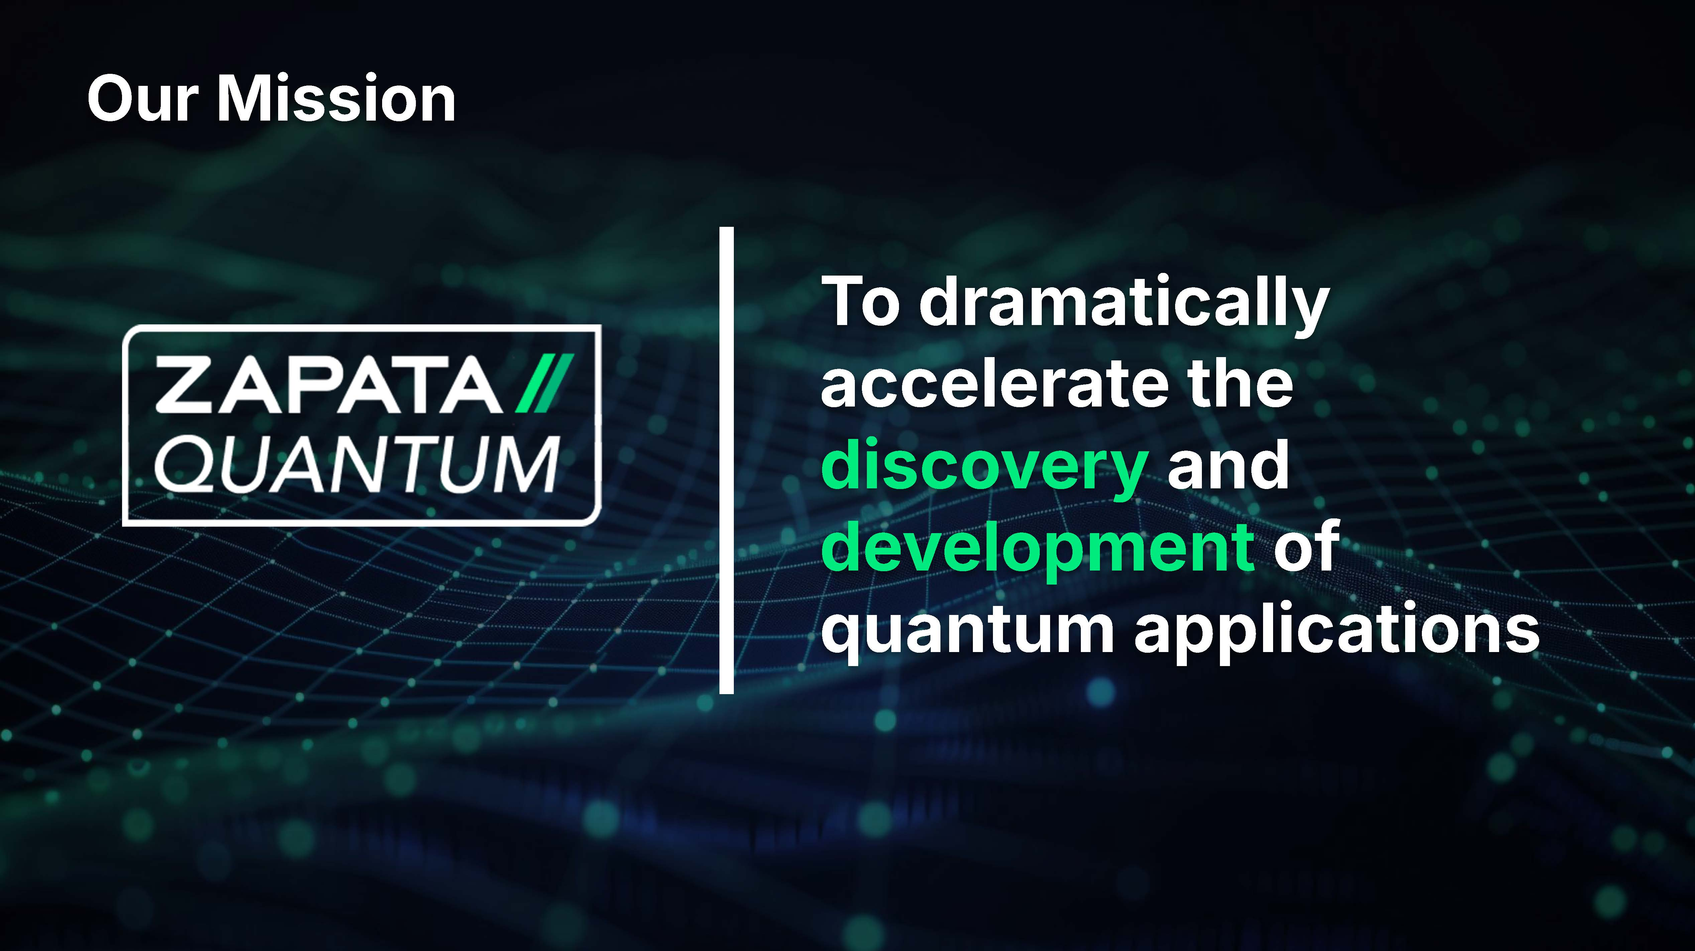
To dramatically accelerate the discovery and development of quantum applications Our Mission
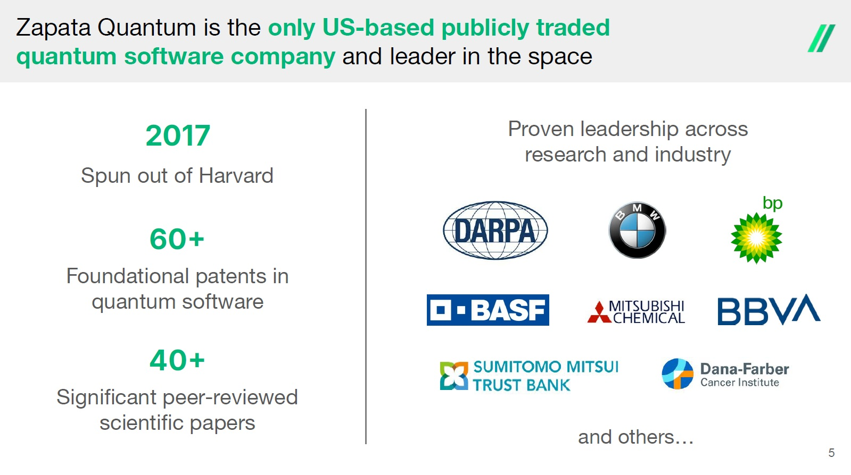
Zapata Quantum is the only US - based publicly traded quantum software company and leader in the space 5 2017 Spun out of Harvard 60  Foundational patents in quantum software 40  Signiﬁcant peer - reviewed scientiﬁc papers Proven leadership across research and industry and others…
Quantum computing has reached an inflection point, driving acceleration of progress and time to value 6 ● Economic value of $2TN in 2035 1 ; $100BN+ platform TAM 2 ● Public / private sector arms races; 90% of value to 10% early movers 3 “Quantum computing is the next frontier and will solve problems we’ve only dreamed of tackling.” - Jensen Huang, CEO “Quantum computing is where AI was ﬁve years ago.” - Sundar Pichai, CEO “The next big accelerator in the cloud will be quantum.” - Satya Nadella, CEO 1. McKinsey Quantum Monitor 2025 2. Company estimate based on SaaS TAM % of value creation 3. BCG estimate
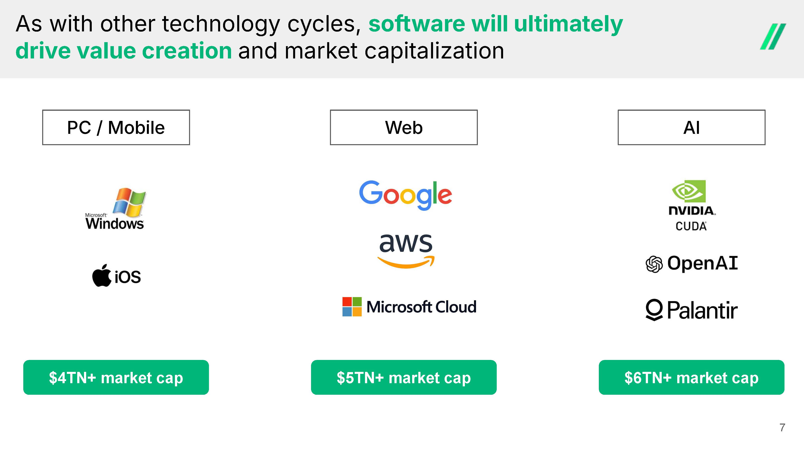
As with other technology cycles, software will ultimately drive value creation and market capitalization 7 PC / Mobile AI Web $4TN+ market cap $5TN+ market cap $6TN+ market cap
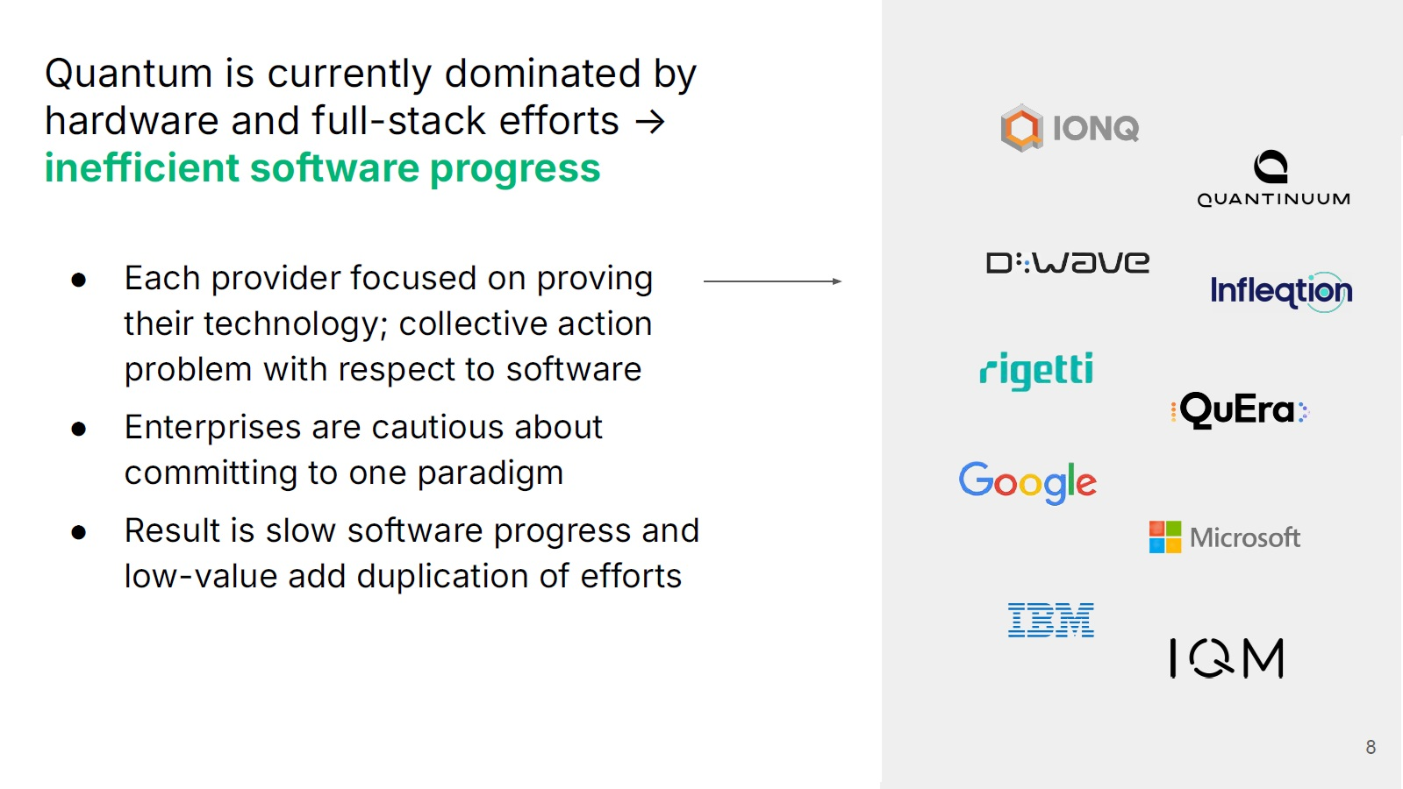
Quantum is currently dominated by hardware and full - stack efforts → inefficient software progress 8 ● Each provider focused on proving their technology ; collective action problem with respect to software ● Enterprises are cautious about committing to one paradigm ● Result is slow software progress and low - value add duplication of efforts
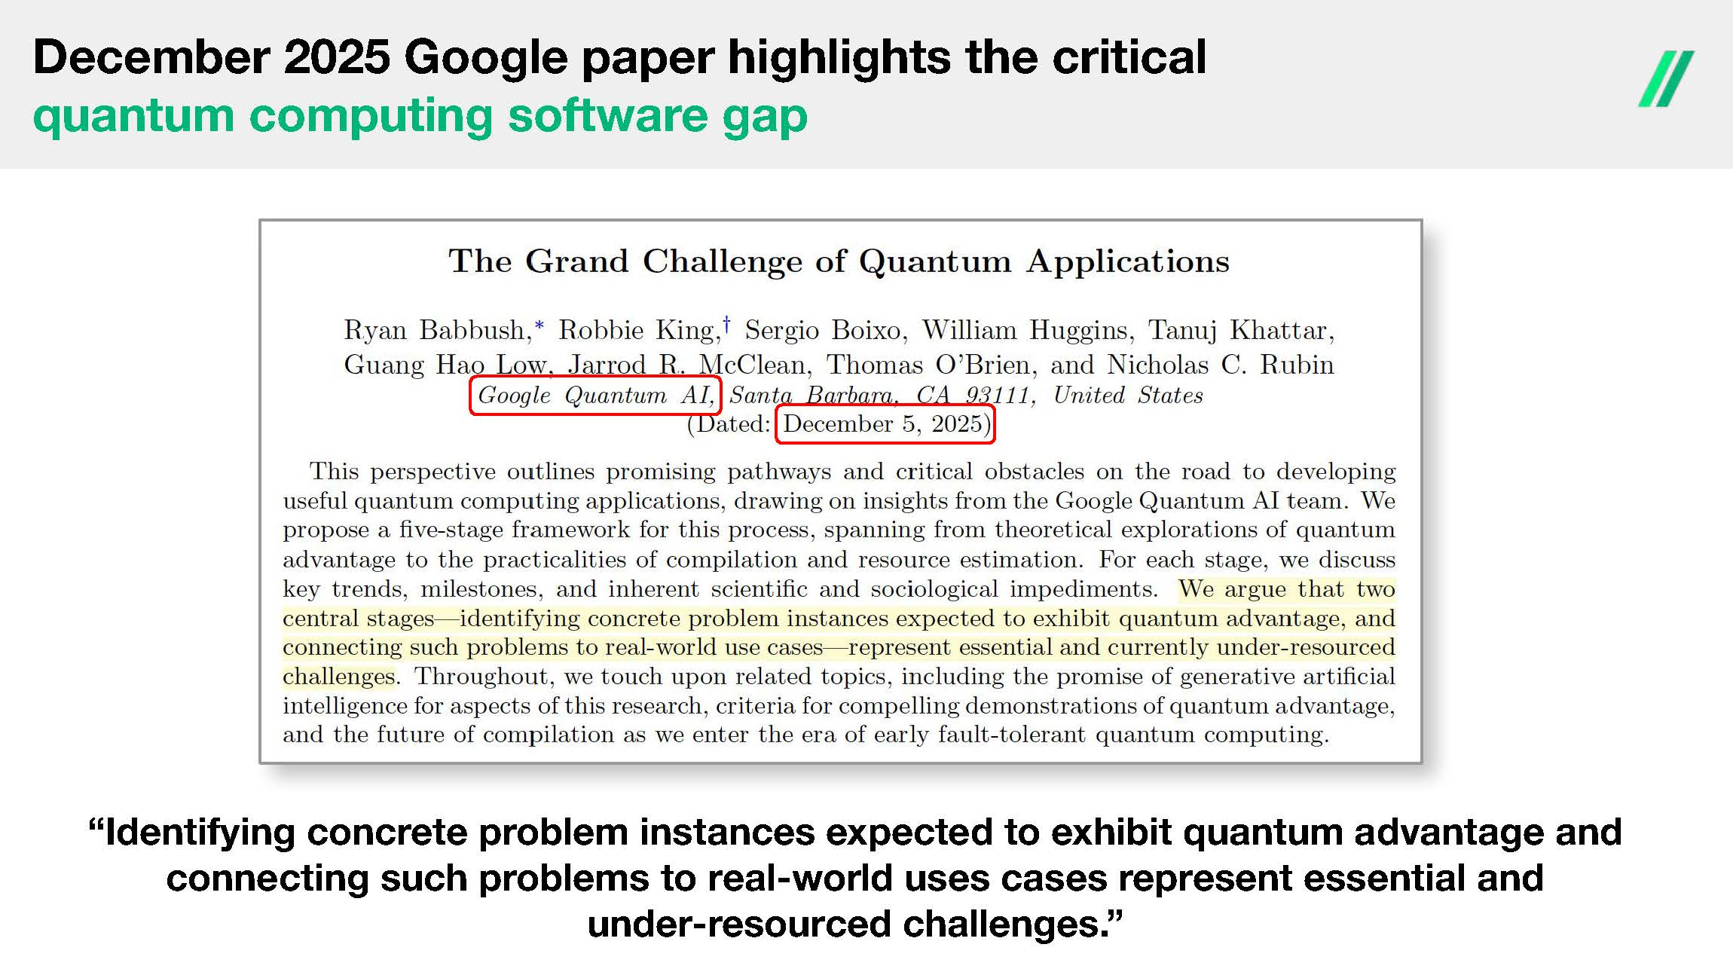
December 2025 Google paper highlights the critical quantum computing software gap “Identifying concrete problem instances expected to exhibit quantum advantage and connecting such problems to real - world uses cases represent essential and under - resourced challenges.”
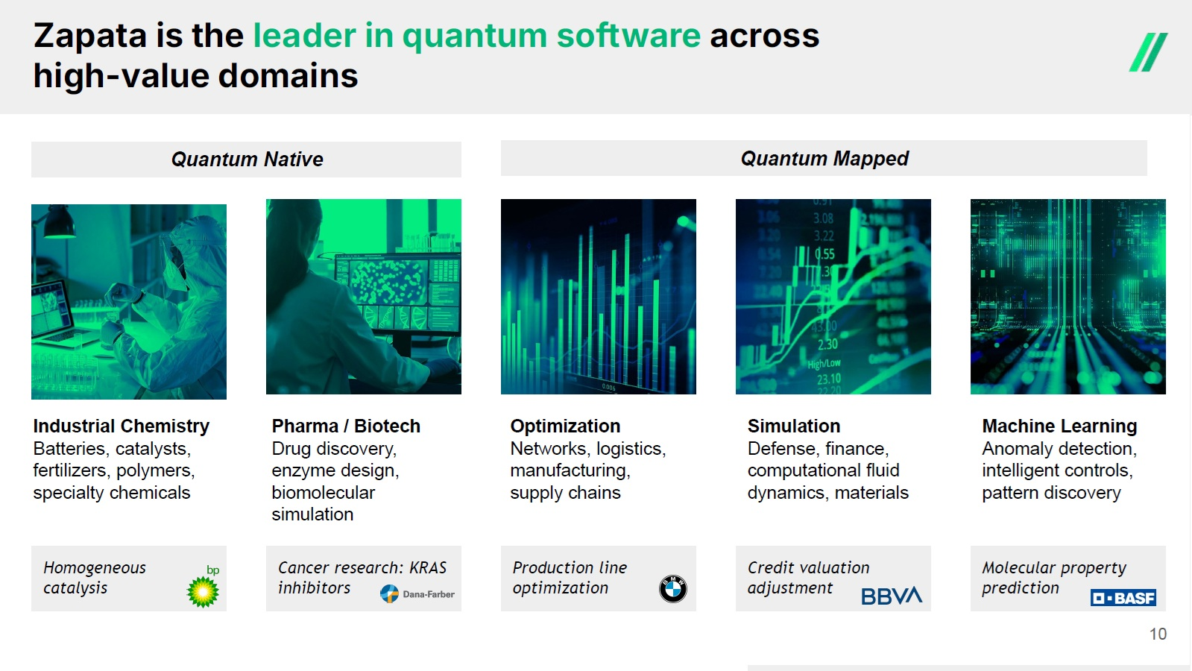
Production line optimization Zapata is the leader in quantum software across high - value domains 10 Quantum Native Quantum Mapped Homogeneous catalysis Industrial Chemistry Batteries, catalysts, fertilizers, polymers, specialty chemicals Cancer research: KRAS inhibitors Optimization Networks, logistics, manufacturing, supply chains Credit valuation adjustment Simulation Defense, finance, computational fluid dynamics, materials Molecular property prediction Machine Learning Anomaly detection, intelligent controls, pattern discovery Pharma / Biotech Drug discovery, enzyme design, biomolecular simulation
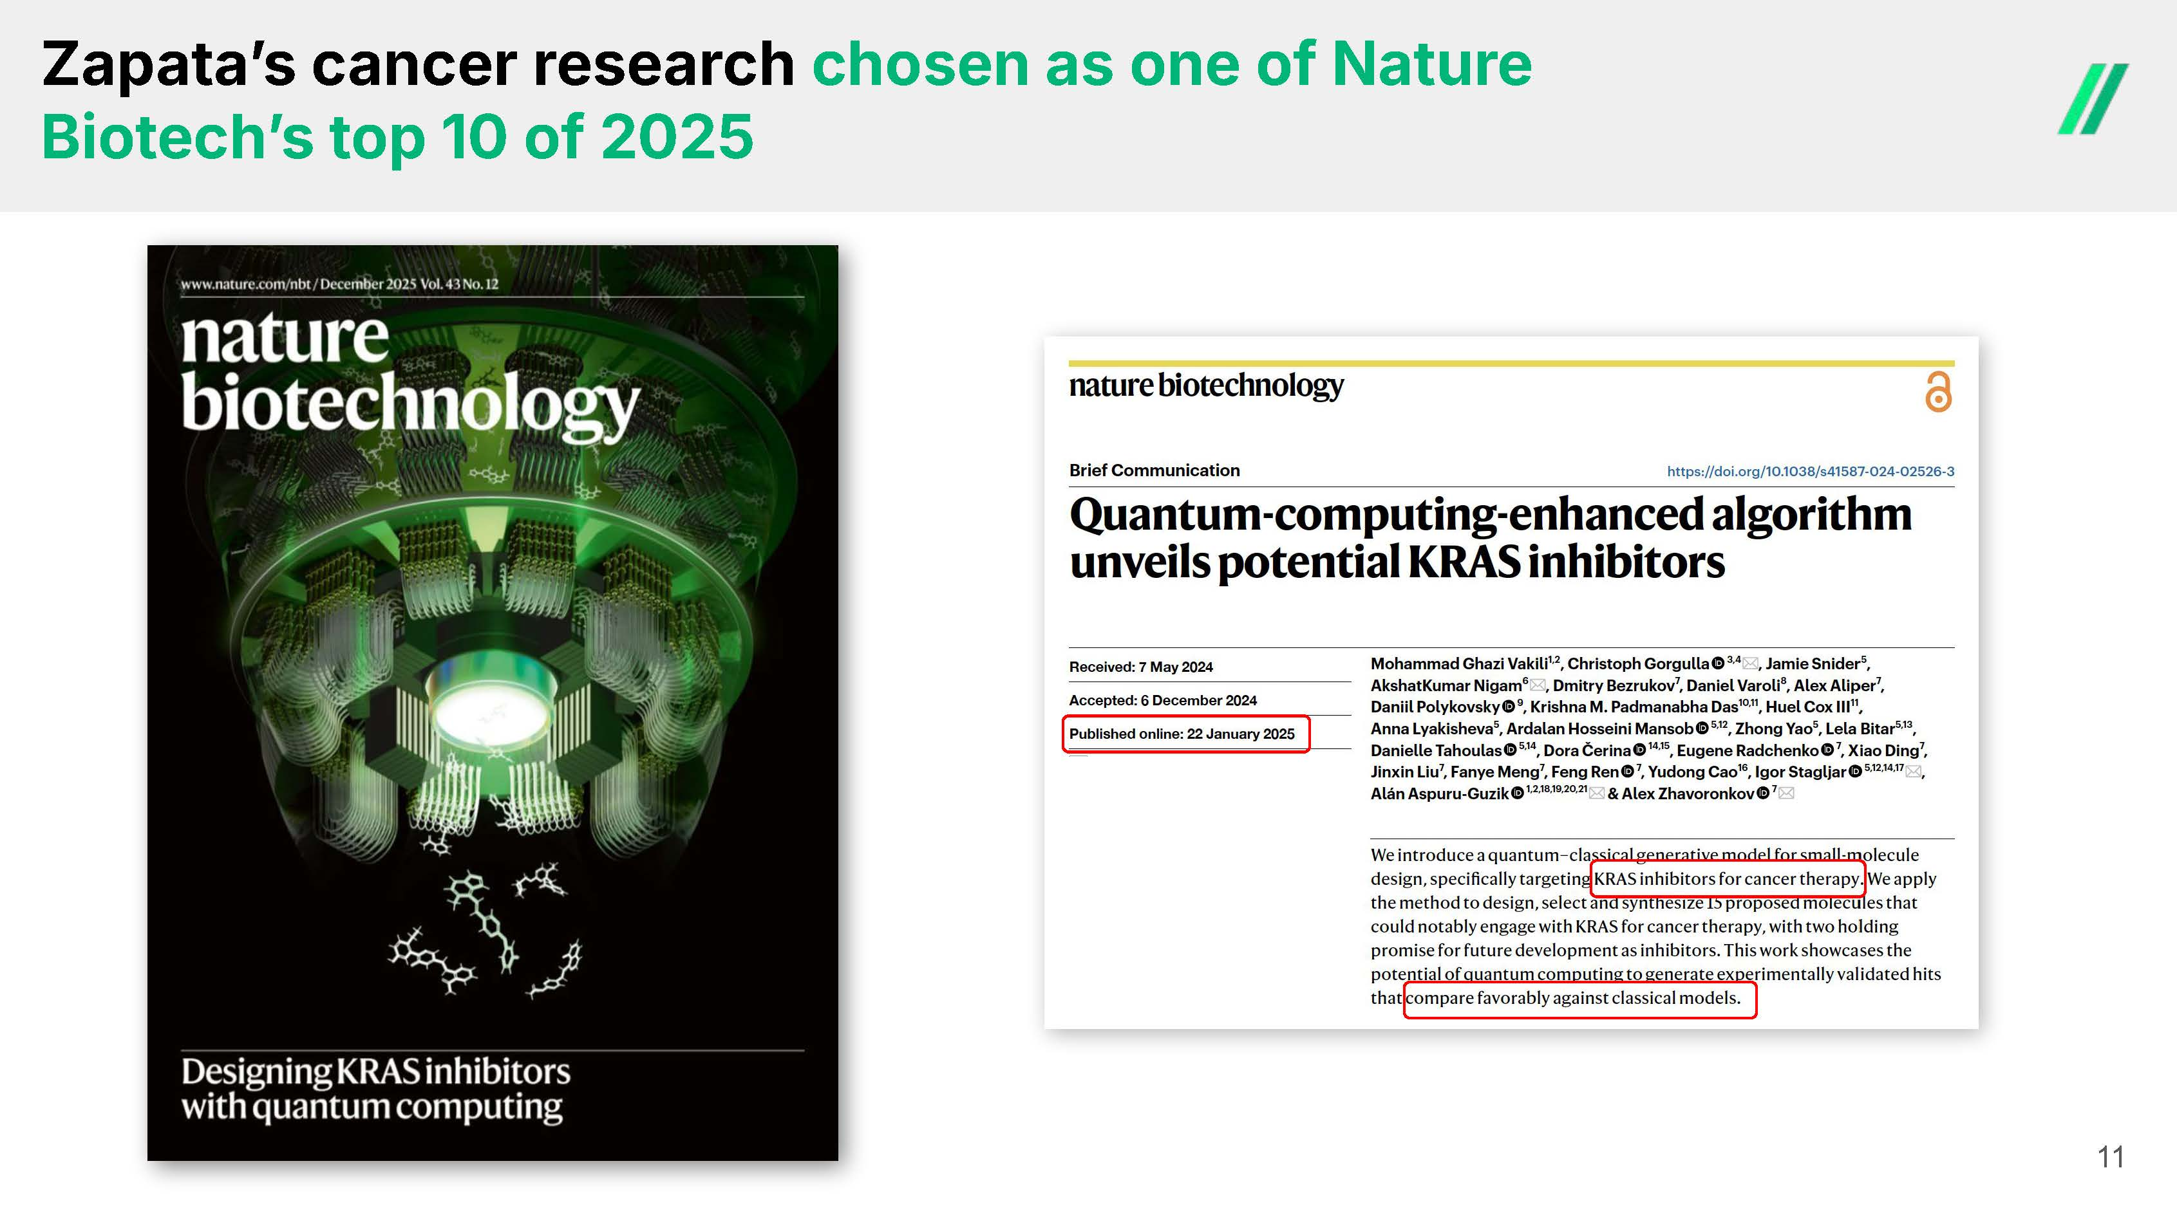
Zapataʼs cancer research chosen as one of Nature Biotechʼs top 10 of 2025 11
The Quantum Computing Application Bottleneck 01 Dynamic landscape "Every plan we write is stale in six months. A roadmap slips, a new algorithm lands, and we're re - evaluating from scratch.” 02 Lack of rigorous assessments “Everyone has an opinion on whether a quantum use case will actually work. What I don't have is a defensible, evidence - based business case that I can take to leadership.” 03 Lack of objectivity "Every vendor's benchmark says they're winning. I need an unbiased evaluation and don’t want to get locked in to any one system.” 04 Little in - house expertise “We don't have a quantum physicist on staff, so we can’t do it alone - and it’s hard to evaluate outside partners.” Organizations struggle with their strategy to discover, develop, and deploy quantum computing applications
Applying AI to the problem…
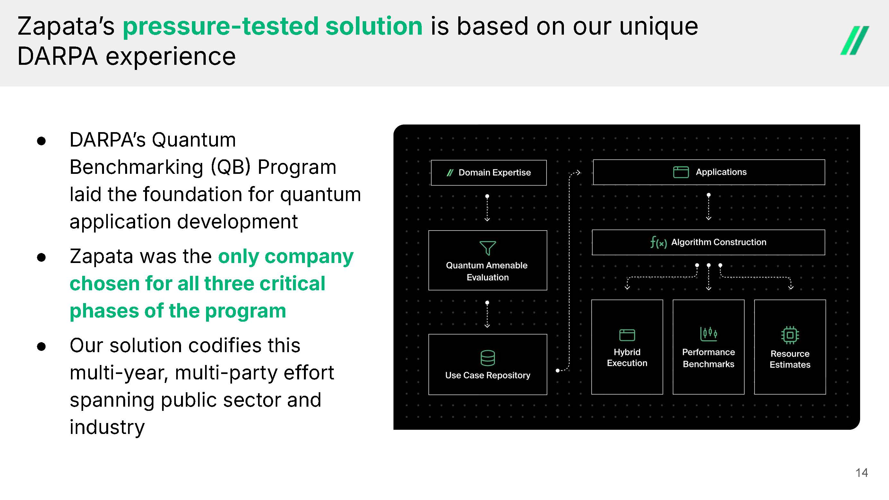
Zapataʼs pressure - tested solution is based on our unique DARPA experience 14 ● DARPAʼs Quantum Benchmarking  QB  Program laid the foundation for quantum application development ● Zapata was the only company chosen for all three critical phases of the program ● Our solution codifies this multi - year, multi - party effort spanning public sector and industry
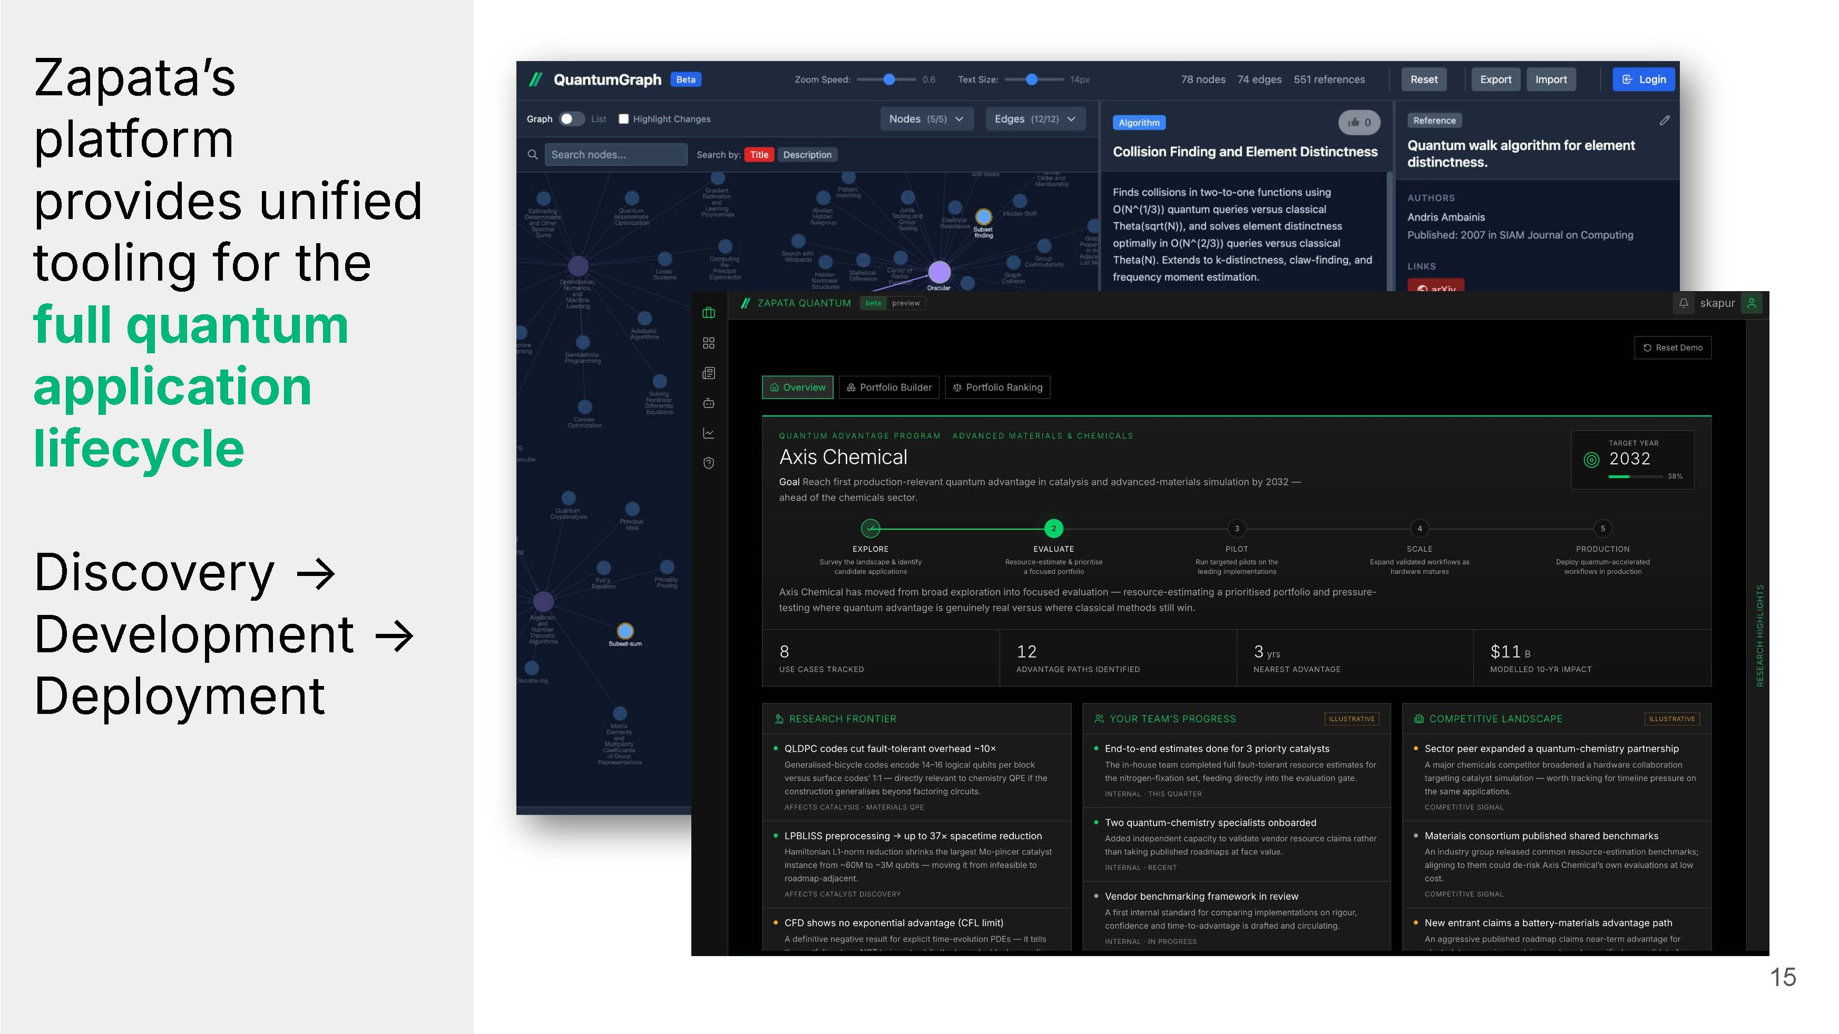
15 Zapataʼs platform provides unified tooling for the full quantum application lifecycle Discovery → Development → Deployment
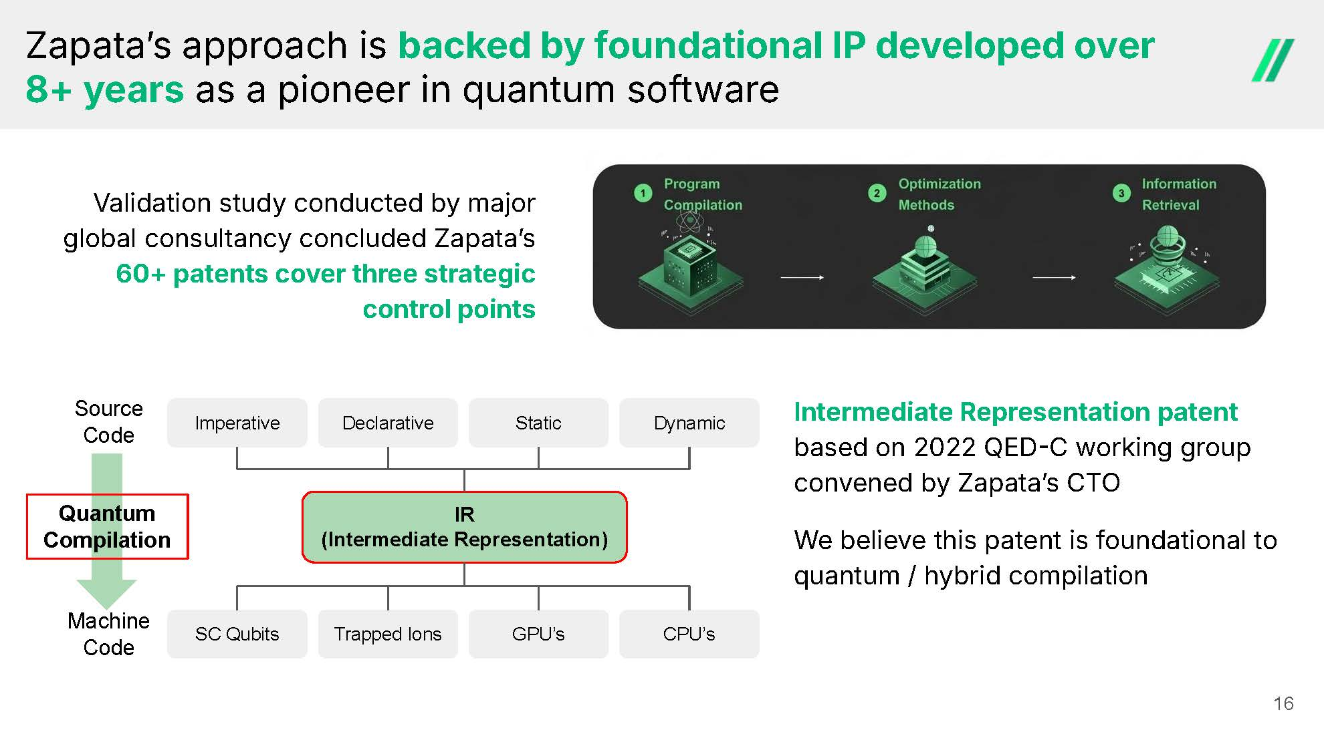
Zapataʼs approach is backed by foundational IP developed over 8+ years as a pioneer in quantum software 16 Imperative Declarative Static Dynamic SC Qubits Trapped Ions GPU’s CPU’s IR (Intermediate Representation) Source Code Machine Code Quantum Compilation Validation study conducted by major global consultancy concluded Zapataʼs 60+ patents cover three strategic control points Intermediate Representation patent based on 2022 QED  C working group convened by Zapataʼs CTO We believe this patent is foundational to quantum / hybrid compilation
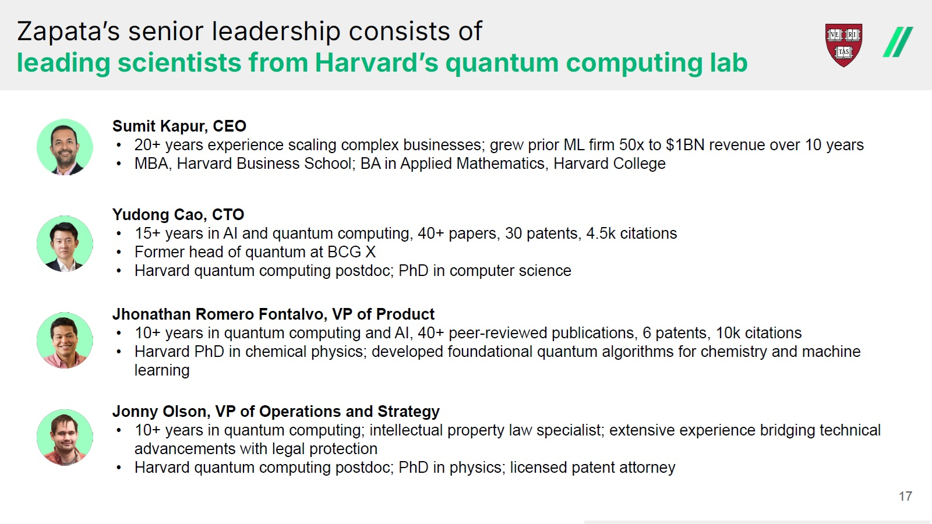
Zapataʼs senior leadership consists of leading scientists from Harvardʼs quantum computing lab Sumit Kapur, CEO • 20+ years experience scaling complex businesses; grew prior ML firm 50x to $1BN revenue over 10 years • MBA, Harvard Business School; BA in Applied Mathematics, Harvard College Yudong Cao, CTO • 15+ years in AI and quantum computing, 40+ papers, 30 patents, 4.5k citations • Former head of quantum at BCG X • Harvard quantum computing postdoc; PhD in computer science Jhonathan Romero Fontalvo, VP of Product • 10+ years in quantum computing and AI, 40+ peer - reviewed publications, 6 patents, 10k citations • Harvard PhD in chemical physics; developed foundational quantum algorithms for chemistry and machine learning Jonny Olson, VP of Operations and Strategy • 10+ years in quantum computing; intellectual property law specialist; extensive experience bridging technical advancements with legal protection • Harvard quantum computing postdoc; PhD in physics; licensed patent attorney 17
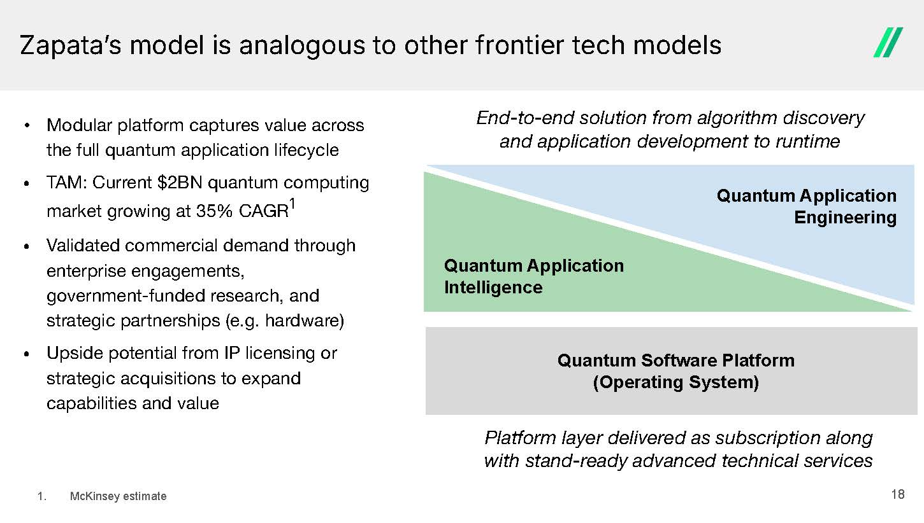
End - to - end solution from algorithm discovery and application development to runtime Quantum Application Engineering Quantum Application Intelligence Quantum Software Platform (Operating System) • Modular platform captures value across the full quantum application lifecycle • TAM: Current $2BN quantum computing market growing at 35% CAGR 1 • Validated commercial demand through enterprise engagements, government - funded research, and strategic partnerships (e.g. hardware) • Upside potential from IP licensing or strategic acquisitions to expand capabilities and value Platform layer delivered as subscription along with stand - ready advanced technical services Zapataʼs model is analogous to other frontier tech models 18 1. McKinsey estimate
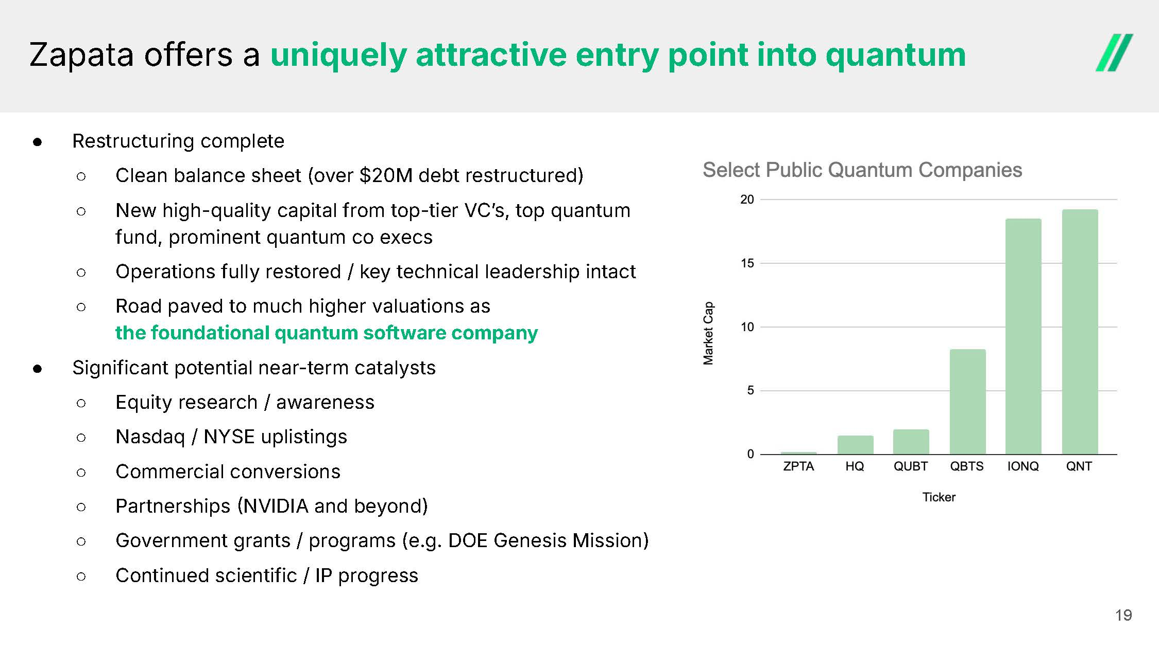
Zapata offers a uniquely attractive entry point into quantum ● Restructuring complete ○ Clean balance sheet (over $20M debt restructured) ○ New high - quality capital from top - tier VCʼs, top quantum fund, prominent quantum co execs ○ Operations fully restored / key technical leadership intact ○ Road paved to much higher valuations as the foundational quantum software company ● Significant potential near - term catalysts ○ Equity research / awareness ○ Nasdaq / NYSE uplistings ○ Commercial conversions ○ Partnerships  NVIDIA and beyond) ○ Government grants / programs (e.g. DOE Genesis Mission) ○ Continued scientific / IP progress 19
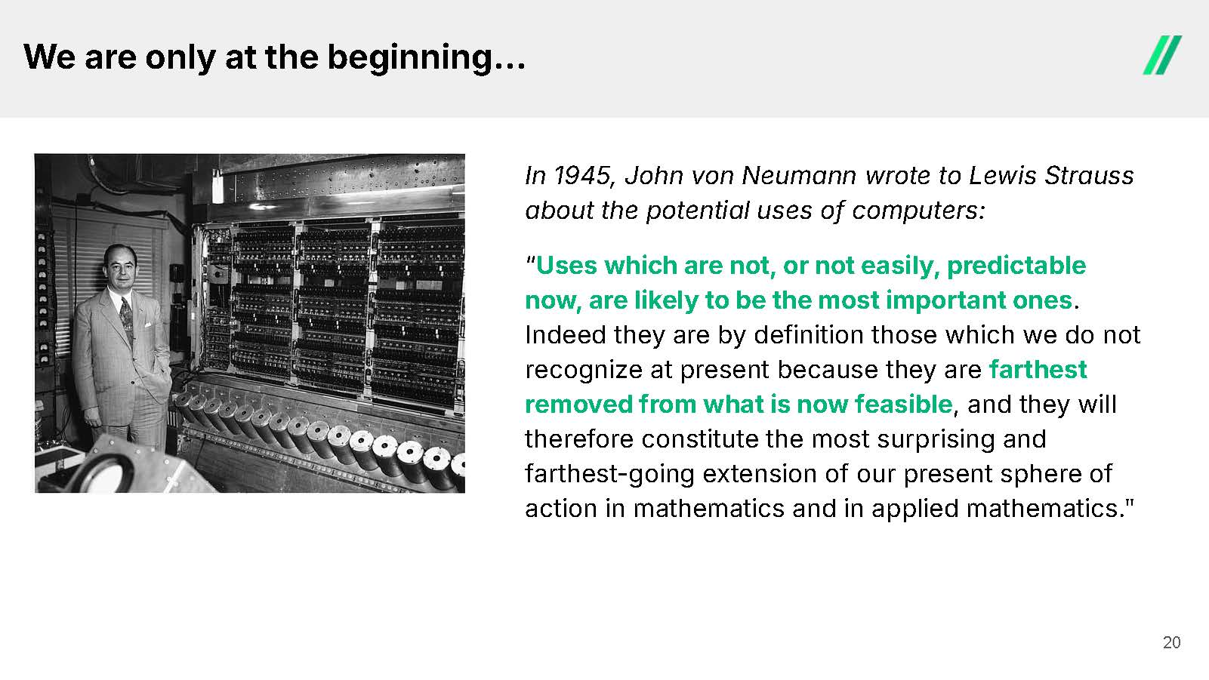
We are only at the beginning… 20 In 1945, John von Neumann wrote to Lewis Strauss about the potential uses of computers: “ Uses which are not, or not easily, predictable now, are likely to be the most important ones . Indeed they are by definition those which we do not recognize at present because they are farthest removed from what is now feasible , and they will therefore constitute the most surprising and farthest - going extension of our present sphere of action in mathematics and in applied mathematics."
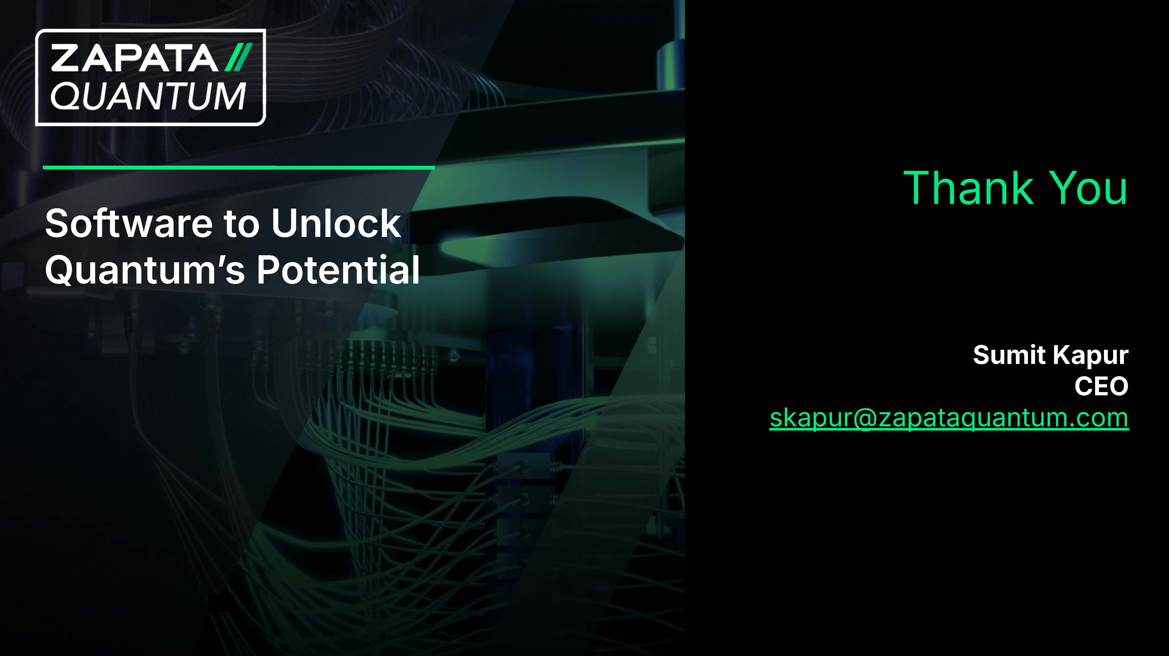
Software to Unlock Quantumʼs Potential Thank You Sumit Kapur CEO skapur@zapataquantum.com

